## Structure

### Material

The material is pre-determined when the team decided to use FEA and destructive bending testing. When the team selects the material, the whole structure is considered to bear high lifting and torsional load. After material study the materials chosen for the wing are:

* Main Spars: Carbon Fiber
* Leading Spars: ¼” Diameter Bass Wood
* Aft Spars: 1/4”x1/8” Bass Wood
* Ribs: 1/16 “ Birch 3-Plywood
* Skin: Monokote

For the Fuselage:

* Main Spars : 1/2”x1/4” Bass wood
* Ribs: 1/8” Birch 6-Plywood
* Skin: Monokote

### Structural Analysis

The software available for our team to accomplish Finite Element Analysis is Femap with NX Nastran. The analyses that will be carried out are stress concentrations and relative deformations. These studies will allow the team to iterate and improve the design the wings.

The wings have three core carbon fiber spars two spanning each side of the wings for rigidity and one spar binding each side of the wings. Also there are leading and trailing spars to resist torsion and add rigidity to the assembly.

In the case of the fuselage the ribs are made from 1/8” Birch 6-Plywood for its rigidity and durability. The spars that span between the ribs are supports to prevent torsion and keep the payload region and aft wing rigid.

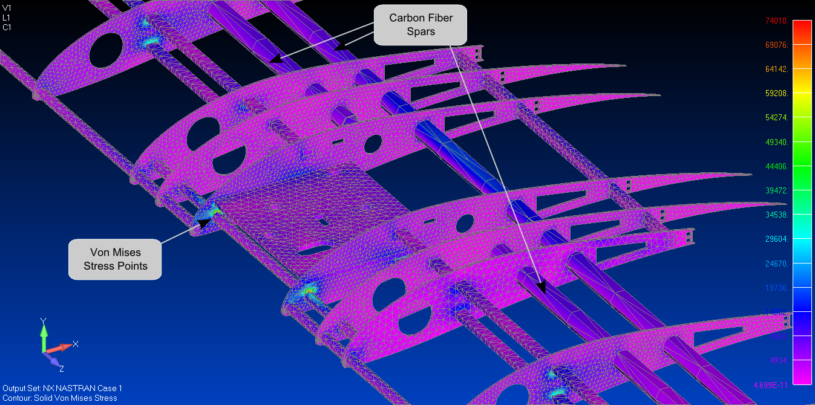

Figure : Wing Core FEA for Three Point Bending (10 lbf load)

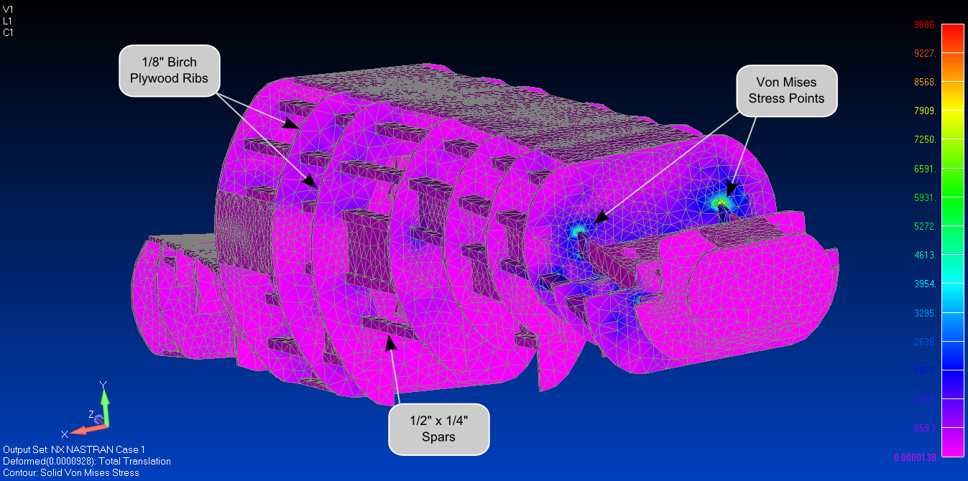

Figure : Fuselage FEA Torsion Test (16 ft-lbf)

### Post Analysis

From the analysis of the wings it has been shown that maximum loading that can be achieved is 10 lbs. This is significantly larger than the expected force of lift on the wings. This is particularly beneficial because payload carrying capacity is critical for the success of each mission. This gives the team flexibility on the design of the external pylons.

Also it can be observed that the key stress points are in the leading and ¼” diameter Bass wood spars and the 1/4” x 1/8” spars passing through the airfoils.

Furthermore the fuselage analysis expresses that the fuselage is very rigid and capable of withstanding the torsions expected during the flight of the aircraft. This will also insure that the flight of the aircraft will be stable and responsive. In the case of the payload, a rigid fuselage will insure that the rocks would not drop prematurely during flight. Comparing the values of the maximum stresses with yield strengths of the material, the design achieves a large factor of safety.